Personal Growth Report
During the project, I learned:
- How to set up the environment for java ee and derby database
- How to code an MVC web app structure
- How to stablish connection between front-end and back-end.

There are several points took me some time doing research online:
- When building the database table, normally we need to create an auto increment column(id) as the table’s index, but I did not find anything on the UI in netbean allow me to do that. After doing some searching, I used the following scripts to create the database.
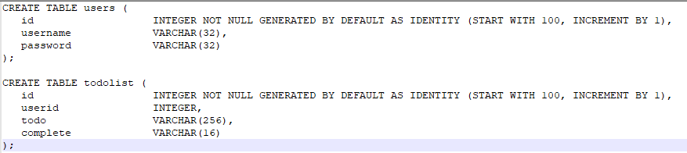
- Also, I could not find a Boolean type on the UI, so in the end I choose pure String and make it strictly equals to “TRUE” or “FALSE”
- MVC structure also took me some time since its complicated and well-structured.

This project took me about 1-2 days to finish.

Personally, I think this project is too complicated and not that useful since these technologies are really outdated. The environment setting process is also struggled, the old version netbean cannot even identify the newest JDK correctly.
I would suggest more projects using newer frameworks such as angular or react instead of jsp.

